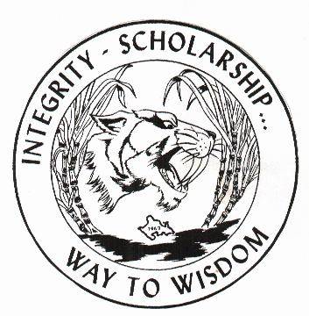

JCHS LOGO
James Campbell
High School
Class of 1980
20th Reunion

Place: Rumours Night Club at the Ala Moana Hotel
Date: Saturday, September 16th, 2000

Time: 3:00pm to 9:00 pm, Class Picture @ 5:00

** Check in no later than 6:00pm**

Dinner Buffet – No Host Bar

Cost: Event is NON-REFUNDABLE
RSVP BY | 1980 Graduate Cost Per Person | Guest Cost Per Person
July 1st, 2000 | $40.00 | $45.00
August 1st, 2000 | $50.00 | $55.00
September 1st, 2000 | $60.00 | $65.00
8 X 10 Class Picture = $15.00
Return Receipt with Payment to: JCHS Class of 1980 20th Reunion
91-153 Waimapuna Place * Ewa Beach, HI 96706 (685-4347)
Name:__________________________________________________________________
Address:________________________________________________________________
Phone:__________________________________________________________________
(Circle One)

# of Graduate/s Attending:_____ x $_______ = ______ Shirt Size MD LG XL XXL XXXL

# of Guest/s Attending:_______ x $_______ = _______ Shirt Size: MD LG XL XXL XXXL
# of Class Pictures ________ x $ _______=_______8 X 10 with mount
Guest Name:_________________________ _________________________________

Make checks payable to: JCHS Class of 1980 20th Reunion

Please enclosed self addressed stamped envelope for reply

We are also accepting monetary and door prize donations!

Tell us about yourself:
How Many Kids ______________ How many Marriage ____________ How Many Divorces___________
How Many Grandchildren______ Hobbies______________________ How Many Animals___________
Please use the back to tell us more………

